Student Code: **30061694**

Student Name: **MUHAMMED ADEBISI**

**TABLES CODES**

CREATE TABLE Potential_Buyer

(BuyerNumber char(8) not null,

Buyer_Name char(20) not null,

Buyer_Address char(50) not null,

Min_Bedroom char,

Min_Bathroom char,

Min_reception char,

Family_Type varchar(12) not null,

GarageRequired char(10),

Max_price number,

constraint Potential_Buyer_BuyerNumber_pk primary key(BuyerNumber));

CREATE TABLE Seller

(SellerNo char(8) not null,

Property_Status char(20),

constraint Seller_SellerNo_pk primary key(SellerNo));

CREATE TABLE Sale_Property

(PropertyCode char(10) not null,

SellerNo char(8) not null,

Area char(20),

Address char(50) not null,

Bedroom_Number char,

Bathroom_Number char,

Reception_Number char,

Garage_status varchar(10),

Property_Type varchar(25) not null,

Price number,

Property_ownership char(20),

Market_Date date,

Property_Current_State char(15),

constraint Sale_Property_PropertyCode_pk primary key(PropertyCode),

constraint Sale_Property_SellerNo_fk Foreign key(SellerNo) references Seller(SellerNo));

CREATE TABLE Staff_Member

(StaffNo varchar(8) not null,

Staff_name char(20) not null,

Staff_address varchar(80),

constraint Staff_Member_StaffNo_pk primary key(StaffNo));

CREATE TABLE Viewing_Appointment

(AppointmentNo char(10) not null,

BuyerNumber char(8) not null,

PropertyCode char(10) not null,

StaffNo varchar(8) not null,

AppointmentDate date,

Appointmenttime char(7) not null,

constraint Viewing_Appointment_AppointmentNo_pk primary key(StaffNo,BuyerNumber,PropertyCode,AppointmentDate,Appointmenttime),

constraint Viewing_Appointment_BuyerNumber_fk foreign key(BuyerNumber) references Potential_Buyer(BuyerNumber),

constraint Viewing_Appointment_PropertyCode_fk foreign key(PropertyCode) references Sale_Property(PropertyCode),

constraint viewing_Appointment_StaffNo_fk foreign key(StaffNo) references Staff_Member(StaffNo));

A 30/30

**TABLES POPULATION CODES**

INSERT INTO

Potential_Buyer(BuyerNumber,Buyer_Name,Buyer_Address,Min_Bedroom,Min_Bathroom,Min_reception,Family_Type,GarageRequired,Max_price)

VALUES('A11065', 'Adekunle Ayomide', '10 Stellamaris Bristol', '2', '1', '1', 'Children', 'yes', 700);

INSERT INTO

Potential_Buyer(BuyerNumber,Buyer_Name,Buyer_Address,Min_Bedroom,Min_Bathroom,Min_reception,Family_Type,GarageRequired,Max_price)

VALUES('A11075', 'Adebisi Muhammed', 'T43 Glamorgan Treforest', '4', '2', '2', 'Children', 'yes', 950);

INSERT INTO

Potential_Buyer(BuyerNumber,Buyer_Name,Buyer_Address,Min_Bedroom,Min_Bathroom,Min_reception,Family_Type,GarageRequired,Max_price)

VALUES('A11088', 'Folami Phola', '30 Wood Road Treforest', '3', '2', '1', 'no Children', 'yes', 800);

INSERT INTO

Potential_Buyer(BuyerNumber,Buyer_Name,Buyer_Address,Min_Bedroom,Min_Bathroom,Min_reception,Family_Type,GarageRequired,Max_price)

VALUES('A11092', 'Emmanuel Fintch', '40 Nepa Swansea', '5', '3', '2', 'Children', 'yes', 1050);

INSERT INTO

Potential_Buyer(BuyerNumber,Buyer_Name,Buyer_Address,Min_Bedroom,Min_Bathroom,Min_reception,Family_Type,GarageRequired,Max_price)

VALUES('A11096', 'Deji USman', 'N13 Glamorgan Treforest', '3', '1', '1', 'no Children', 'yes', 750);

INSERT INTO

Potential_Buyer(BuyerNumber,Buyer_Name,Buyer_Address,Min_Bedroom,Min_Bathroom,Min_reception,Family_Type,GarageRequired,Max_price)

VALUES('A11083', 'Sorewei Evelyn', 'P12 Glamorgan Pontypridd', '2', '1', '1', 'no Children', 'no', 600);

INSERT INTO

Potential_Buyer(BuyerNumber,Buyer_Name,Buyer_Address,Min_Bedroom,Min_Bathroom,Min_reception,Family_Type,GarageRequired,Max_price)

VALUES('A11066', 'Dantata Haliyah', '15 Justin Avonmouth', '2', '1', '1', 'Children', 'yes', 500);

INSERT INTO

Potential_Buyer(BuyerNumber,Buyer_Name,Buyer_Address,Min_Bedroom,Min_Bathroom,Min_reception,Family_Type,GarageRequired,Max_price)

VALUES('A11072', 'Christian Madu', 'T03 Savanna Bridgend', '4', '1', '2', 'Children', 'yes', 1000);

INSERT INTO

Potential_Buyer(BuyerNumber,Buyer_Name,Buyer_Address,Min_Bedroom,Min_Bathroom,Min_reception,Family_Type,GarageRequired,Max_price)

VALUES('A11089', 'Olaniyan Sodiq', '33 Salt Road Aberdare', '3', '2', '1', 'no Children', 'yes', 700);

INSERT INTO

Potential_Buyer(BuyerNumber,Buyer_Name,Buyer_Address,Min_Bedroom,Min_Bathroom,Min_reception,Family_Type,GarageRequired,Max_price)

VALUES('A11091', 'Aliko musa', '19 Brick Blackwood', '4', '3', '2', 'Children', 'yes', 950);

INSERT INTO

Potential_Buyer(BuyerNumber,Buyer_Name,Buyer_Address,Min_Bedroom,Min_Bathroom,Min_reception,Family_Type,GarageRequired,Max_price)

VALUES('A11095', 'Amoo Temitayo', 'N18 Glamorgan Carthys', '3', '1', '1', 'no Children', 'yes', 750);

INSERT INTO

Potential_Buyer(BuyerNumber,Buyer_Name,Buyer_Address,Min_Bedroom,Min_Bathroom,Min_reception,Family_Type,GarageRequired,Max_price)

VALUES('A11081', 'Madu Dantata', 'S02 Glamorgan Cardiff', '2', '1', '1', 'no Children', 'no', 600);

INSERT INTO

Seller(SellerNo,Property_Status)

VALUES ('SP1004','Null');

INSERT INTO

Seller(SellerNo,Property_Status)

VALUES('SP1006', 'Null');

INSERT INTO

Seller(SellerNo,Property_Status)

VALUES('SP1007', 'Null');

INSERT INTO

Seller(SellerNo,Property_Status)

VALUES('SP1008', 'sold');

INSERT INTO

Seller(SellerNo,Property_Status)

VALUES('SP1010', 'Null');

INSERT INTO

Seller(SellerNo,Property_Status)

VALUES('SP1012', 'Sold');

INSERT INTO

Seller(SellerNo,Property_Status)

VALUES ('SP1009','Null');

INSERT INTO

Seller(SellerNo,Property_Status)

VALUES('SP1014', 'Null');

INSERT INTO

Seller(SellerNo,Property_Status)

VALUES('SP1026', 'Null');

INSERT INTO

Seller(SellerNo,Property_Status)

VALUES('SP1032', 'sold');

INSERT INTO

Seller(SellerNo,Property_Status)

VALUES('SP1047', 'Null');

INSERT INTO

Seller(SellerNo,Property_Status)

VALUES('SP1038', 'Sold');

INSERT INTO

Staff_Member(StaffNo,Staff_name,Staff_address)

VALUES('M0012','Bill Clinton','T3 Simpson aberdare');

INSERT INTO

Staff_Member(StaffNo,Staff_name,Staff_address)

VALUES('M0010','Sean Jane','N0 10 Cornerstone Swansea');

INSERT INTO

Staff_Member(StaffNo,Staff_name,Staff_address)

VALUES('M0008','Nanu Osberg','3 Onward Carthys');

INSERT INTO

Staff_Member(StaffNo,Staff_name,Staff_address)

VALUES('M0007','Free Bossman','16 Treewood Avonmouth');

INSERT INTO

Staff_Member(StaffNo,Staff_name,Staff_address)

VALUES('M0014','Lisa Laura','4 Moonnight Pontypridd');

INSERT INTO

Staff_Member(StaffNo,Staff_name,Staff_address)

VALUES('M0016','Ben Bruce','15 Wood Road Cardiff');

INSERT INTO

Staff_Member(StaffNo,Staff_name,Staff_address)

VALUES('M0013','Freeman Wood','M2 Gaps Pontypridd');

INSERT INTO

Staff_Member(StaffNo,Staff_name,Staff_address)

VALUES('M0019','Qing Ma','N0 12 Bath Swansea');

INSERT INTO

Staff_Member(StaffNo,Staff_name,Staff_address)

VALUES('M0028','Jeremih Fust','4 Ward Cardiff');

INSERT INTO

Staff_Member(StaffNo,Staff_name,Staff_address)

VALUES('M0057','David Mane','18 Becks Blackwood');

INSERT INTO

Staff_Member(StaffNo,Staff_name,Staff_address)

VALUES('M0044','Brooke Sandra','2 Lidnight Porth');

INSERT INTO

Staff_Member(StaffNo,Staff_name,Staff_address)

VALUES('M0036','Ming Lee','11 Member Cardiff');

INSERT INTO

Sale_Property(PropertyCode,SellerNo,Area,Address,Bedroom_Number,Bathroom_Number,Reception_Number,Garage_Status,Property_Type,Price,Property_Ownership,Market_Date,Property_Current_State)

VALUES('PC10063','SP1004','Pontypridd','M10 Wood Road','4','2','1','Yes','Detached',950,'freehold','03-JUN-2022','Unsold');

INSERT INTO

Sale_Property(PropertyCode,SellerNo,Area,Address,Bedroom_Number,Bathroom_Number,Reception_Number,Garage_Status,Property_Type,Price,Property_Ownership,Market_Date,Property_Current_State)

VALUES('PC10065','SP1010','Pontypridd','Y5 Bucketty','3','2','1','Yes','Terrace',800,'leasehold','15-MAY-2022','Unsold');

INSERT INTO

Sale_Property(PropertyCode,SellerNo,Area,Address,Bedroom_Number,Bathroom_Number,Reception_Number,Garage_Status,Property_Type,Price,Property_Ownership,Market_Date,Property_Current_State)

VALUES('PC10058','SP1006','Swansea','No15 Forest Groove','5','2','2','Yes','Semi-Detached',1100,'freehold','20-APR-2022','Unsold');

INSERT INTO

Sale_Property(PropertyCode,SellerNo,Area,Address,Bedroom_Number,Bathroom_Number,Reception_Number,Garage_Status,Property_Type,Price,Property_Ownership,Market_Date,Property_Current_State)

VALUES('PC10048','SP1012','Cardiff','T16 Morgan Base','3','1','1','Yes','Link',750,'freehold','15-JAN-2022','Sold');

INSERT INTO

Sale_Property(PropertyCode,SellerNo,Area,Address,Bedroom_Number,Bathroom_Number,Reception_Number,Garage_Status,Property_Type,Price,Property_Ownership,Market_Date,Property_Current_State)

VALUES('PC10043','SP1007','Newport','Memorial Road','2','1','1','No','Terrace',650,'freehold','03-MAR-2022','Unsold');

INSERT INTO

Sale_Property(PropertyCode,SellerNo,Area,Address,Bedroom_Number,Bathroom_Number,Reception_Number,Garage_Status,Property_Type,Price,Property_Ownership,Market_Date,Property_Current_State)

VALUES('PC10052','SP1008','Bridgend','Old Legacy Road','4','2','1','Yes','Semi-Detached',950,'leasehold','10-FEB-2022','Sold');

INSERT INTO

Sale_Property(PropertyCode,SellerNo,Area,Address,Bedroom_Number,Bathroom_Number,Reception_Number,Garage_Status,Property_Type,Price,Property_Ownership,Market_Date,Property_Current_State)

VALUES('PC10081','SP1009','Pontypridd','M10 Farm Road','4','2','1','Yes','Detached',930,'freehold','16-JUN-2022','Unsold');

INSERT INTO

Sale_Property(PropertyCode,SellerNo,Area,Address,Bedroom_Number,Bathroom_Number,Reception_Number,Garage_Status,Property_Type,Price,Property_Ownership,Market_Date,Property_Current_State)

VALUES('PC10028','SP1014','Pontypridd','T9 SPacetown','3','2','1','Yes','Terrace',850,'leasehold','18-MAY-2022','Unsold');

INSERT INTO

Sale_Property(PropertyCode,SellerNo,Area,Address,Bedroom_Number,Bathroom_Number,Reception_Number,Garage_Status,Property_Type,Price,Property_Ownership,Market_Date,Property_Current_State)

VALUES('PC10015','SP1026','Swansea','No25 Church Street','6','3','2','Yes','Semi-Detached',1200,'freehold','19-APR-2022','Unsold');

INSERT INTO

Sale_Property(PropertyCode,SellerNo,Area,Address,Bedroom_Number,Bathroom_Number,Reception_Number,Garage_Status,Property_Type,Price,Property_Ownership,Market_Date,Property_Current_State)

VALUES('PC10029','SP1032','Cardiff','W12 Baseline','4','2','1','Yes','Link',850,'freehold','13-JAN-2022','Sold');

INSERT INTO

Sale_Property(PropertyCode,SellerNo,Area,Address,Bedroom_Number,Bathroom_Number,Reception_Number,Garage_Status,Property_Type,Price,Property_Ownership,Market_Date,Property_Current_State)

VALUES('PC10093','SP1047','Newport','Phil Simp Road','2','1','1','No','Terrace',660,'freehold','07-MAR-2022','Unsold');

INSERT INTO

Sale_Property(PropertyCode,SellerNo,Area,Address,Bedroom_Number,Bathroom_Number,Reception_Number,Garage_Status,Property_Type,Price,Property_Ownership,Market_Date,Property_Current_State)

VALUES('PC10075','SP1038','Bridgend','New Waterland Road','4','2','1','Yes','Semi-Detached',900,'leasehold','13-FEB-2022','Sold');

INSERT INTO

Viewing_Appointment(AppointmentNo,BuyerNumber,PropertyCode,StaffNo,AppointmentDate,Appointmenttime)

VALUES('NP1006','A11065','PC10063','M0012','06-JAN-2023','12:00');

INSERT INTO

Viewing_Appointment(AppointmentNo,BuyerNumber,PropertyCode,StaffNo,AppointmentDate,Appointmenttime)

VALUES('NP1008','A11075','PC10065','M0010','28-NOV-2022','14:00');

INSERT INTO

Viewing_Appointment(AppointmentNo,BuyerNumber,PropertyCode,StaffNo,AppointmentDate,Appointmenttime)

VALUES('NP1010','A11088','PC10058','M0008','04-DEC-2022','15:00');

INSERT INTO

Viewing_Appointment(AppointmentNo,BuyerNumber,PropertyCode,StaffNo,AppointmentDate,Appointmenttime)

VALUES('NP1012','A11092','PC10048','M0007','15-NOV-2022','12:00');

INSERT INTO

Viewing_Appointment(AppointmentNo,BuyerNumber,PropertyCode,StaffNo,AppointmentDate,Appointmenttime)

VALUES('NP1023','A11096','PC10043','M0014','20-DEC-2022','10:00');

INSERT INTO

Viewing_Appointment(AppointmentNo,BuyerNumber,PropertyCode,StaffNo,AppointmentDate,Appointmenttime)

VALUES('NP1014','A11083','PC10052','M0016','12-NOV-2022','09:30');

INSERT INTO

Viewing_Appointment(AppointmentNo,BuyerNumber,PropertyCode,StaffNo,AppointmentDate,Appointmenttime)

VALUES('NP1009','A11066','PC10081','M0013','02-DEc-2022','13:00');

INSERT INTO

Viewing_Appointment(AppointmentNo,BuyerNumber,PropertyCode,StaffNo,AppointmentDate,Appointmenttime)

VALUES('NP1011','A11072','PC10028','M0019','04-JAN-2023','12:00');

INSERT INTO

Viewing_Appointment(AppointmentNo,BuyerNumber,PropertyCode,StaffNo,AppointmentDate,Appointmenttime)

VALUES('NP1013','A11089','PC10015','M0028','07-DEC-2022','10:00');

INSERT INTO

Viewing_Appointment(AppointmentNo,BuyerNumber,PropertyCode,StaffNo,AppointmentDate,Appointmenttime)

VALUES('NP1041','A11091','PC10029','M0057','13-NOV-2022','12:00');

INSERT INTO

Viewing_Appointment(AppointmentNo,BuyerNumber,PropertyCode,StaffNo,AppointmentDate,Appointmenttime)

VALUES('NP1032','A11095','PC10093','M0044','28-NOV-2022','15:00');

INSERT INTO

Viewing_Appointment(AppointmentNo,BuyerNumber,PropertyCode,StaffNo,AppointmentDate,Appointmenttime)

VALUES('NP1033','A11081','PC10075','M0036','08-NOV-2022','10:30');

SELECT *

FROM Potential_Buyer;

SELECT *

FROM Seller;

SELECT *

FROM Staff_Member;

SELECT *

FROM Sale_Property;

SELECT *

FROM Viewing_Appointment;

**POPULATION TABLES**

* Potential_Buyer

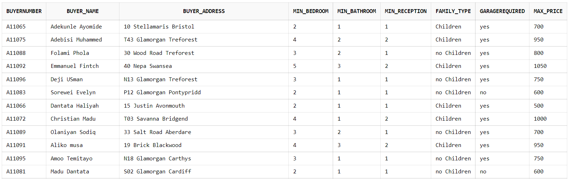

* Seller

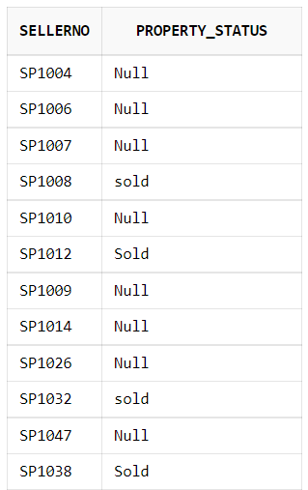

* Sales_Property

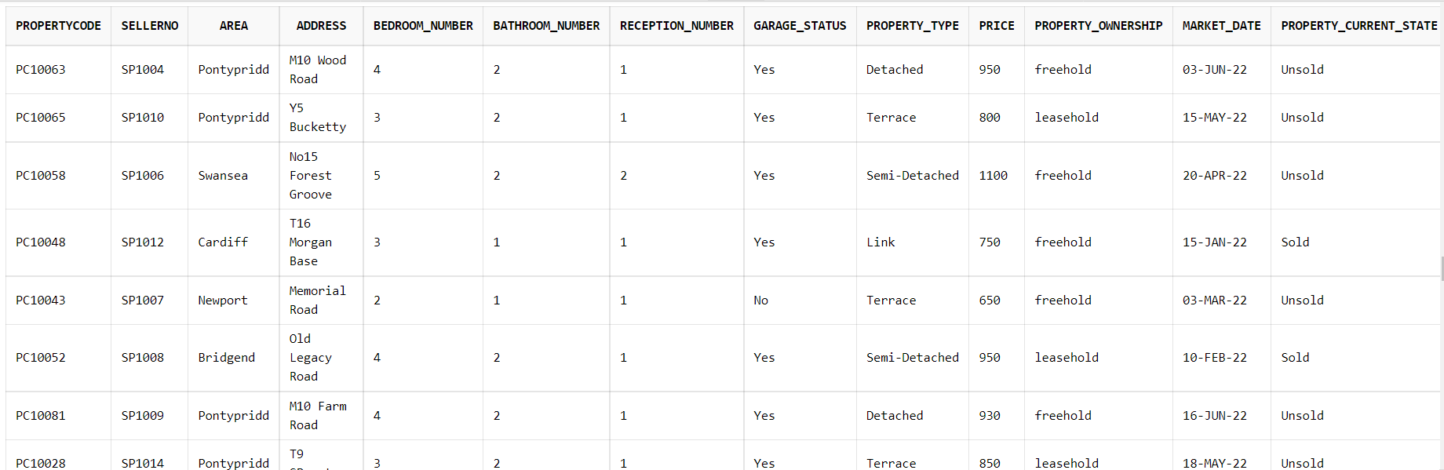

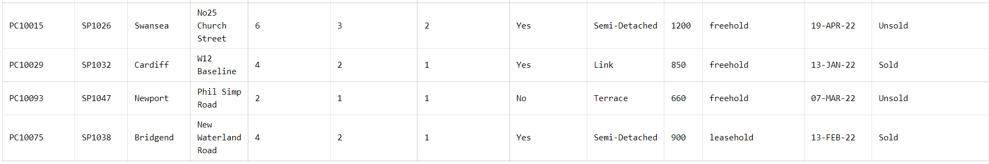

* Viewing_Appointment

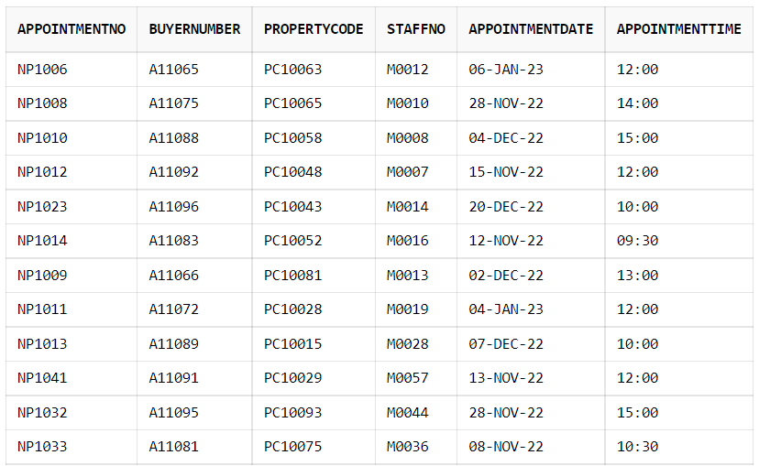

* Staff_Member

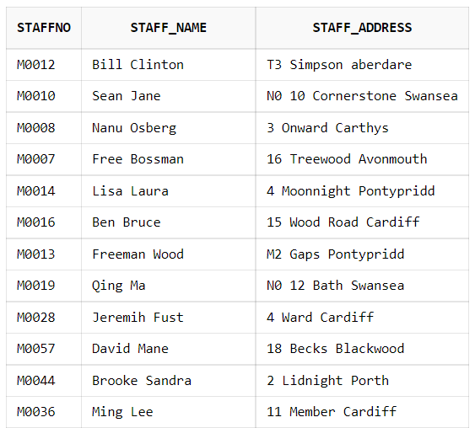

B 5/5

**ANSWERS TO THE QUESTIONS**

**QUESTION ONE (1):**

SELECT PropertyCode,SellerNo,Area,Address,Bedroom_Number,Bathroom_Number,Reception_Number,Garage_Status,Property_Type,Price,Property_Ownership,Market_Date,Property_Current_State

FROM Sale_Property

WHERE Area IN ('Pontypridd');

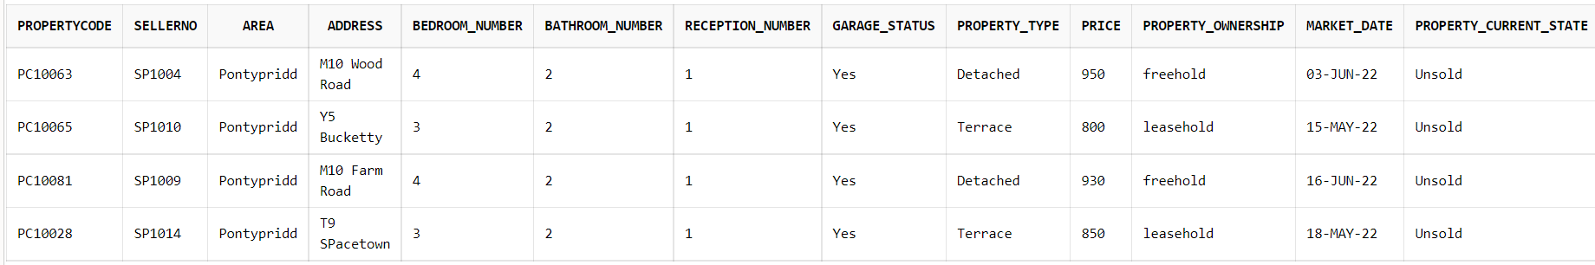

3/3

**QUESTION TWO (2):**

SELECT PropertyCode,SellerNo,Area,Address,Bedroom_Number,Bathroom_Number,Reception_Number,Garage_Status,Property_Type,Price,Property_Ownership,Market_Date,Property_Current_State

FROM Sale_Property

WHERE Property_Type IN ('Semi-Detached')

AND Property_Current_State IN ('Sold');

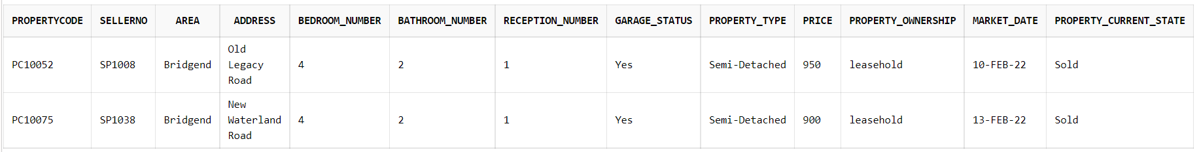

4/4

**QUESTION THREE (3):**

SELECT Property_Type AS Type,COUNT(Property_Current_State) AS Number_Sold

FROM Sale_Property

WHERE Property_Current_State IN ('Sold')

GROUP BY Property_Type,Property_Current_State;

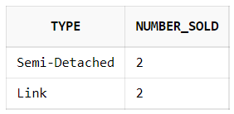

6/6

**QUESTION FOUR (4):**

SELECT *

FROM Sale_Property

WHERE Price IN (SELECT MAX(Price) FROM Sale_Property)

OR Price IN(SELECT MIN(Price) FROM Sale_Property);

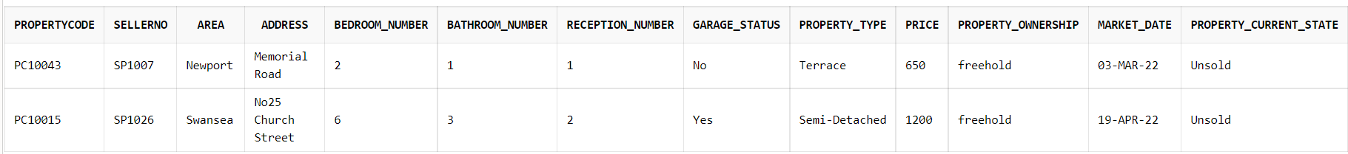

Where property is unsold (not sold) minus 2

4/6 + 2

**QUESTION FIVE (5):**

SELECT PropertyCode,SellerNo,Area,Address,Bedroom_Number,Bathroom_Number,Reception_Number,Garage_Status,Property_Type,Price,Property_Ownership,Market_Date,Property_Current_State

FROM Sale_Property

WHERE Bedroom_Number >=3 AND Bathroom_Number >=1

AND Garage_Status IN ('Yes');

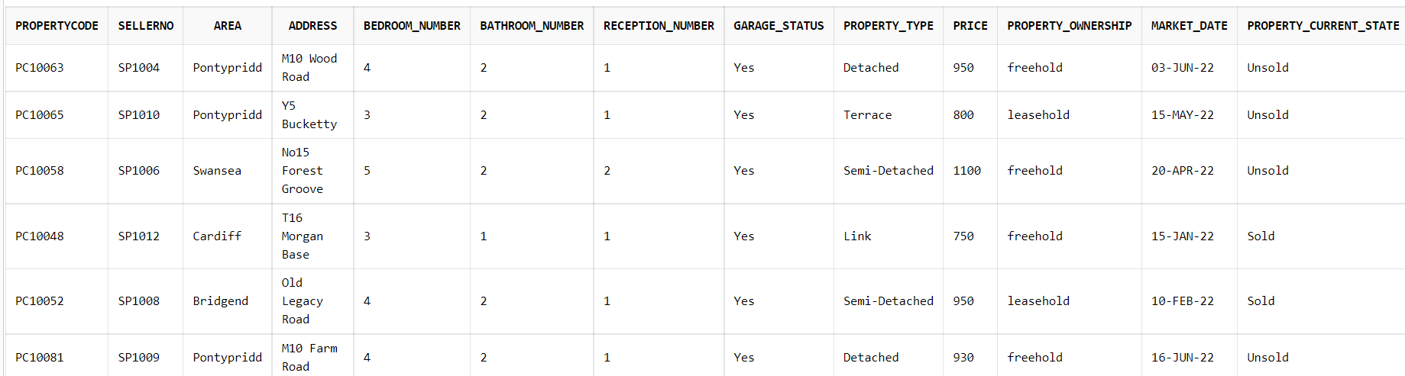

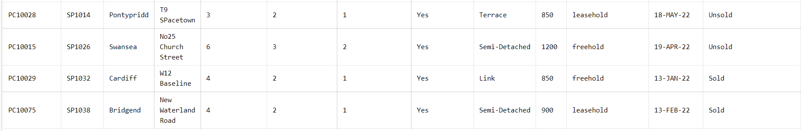

6/6

**QUESTION SIX (6):**

SELECT *

FROM Sale_Property

WHERE Market_Date BETWEEN '01-JAN-2022' AND '28-FEB-2022';

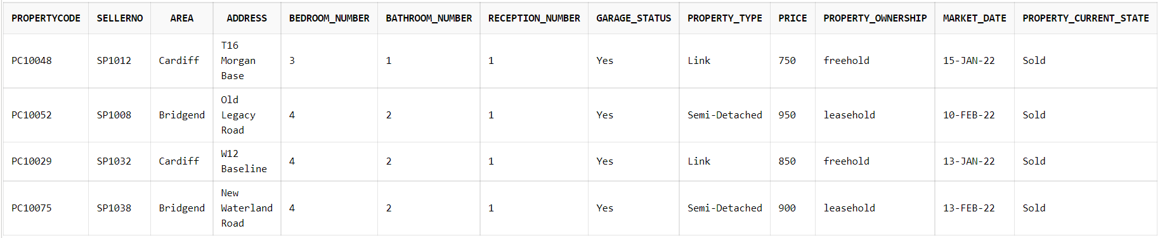

6/6

**QUESTION SEVEN (7):**

SELECT Property_Type,MAX(Price) AS Most_Expensive, MIN(Price) AS Least_Expensive

FROM Sale_Property

GROUP BY Property_Type;

6/6

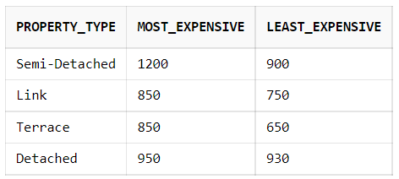

**QUESTION EIGHT (8):**

SELECT V. AppointmentNo,V. BuyerNumber,V. PropertyCode,V. AppointmentDate,V. Appointmenttime, 'Supervised By',S. Staff_name, V. StaffNo

FROM Viewing_Appointment V, Staff_Member S

WHERE V. StaffNo = S. StaffNo AND S. Staff_name = 'Lisa Laura';



8/8

**QUESTION NINE (9):**

The first thing we need to do, is to add seller name to Seller and put some values(populate), as follows

**Code and population**:

ALTER TABLE Seller

ADD SellerName VARCHAR(20);

update Seller

set SellerName='A. Fella'

where SellerNo='SP1006';

update Seller

set SellerName= 'C. Bams'

Where SellerNo='SP1004';

Update Seller

set SellerName='P. Morgan'

Where SellerNo='SP1007';

update Seller

set SellerName='F. Allen'

Where SellerNo='SP1008';

update Seller

set SellerName='M. Felix'

Where SellerNo='SP1010';

update Seller

set SellerName='Sam Chang'

Where SellerNo='SP1012';

update Seller

set SellerName='D. Perez'

Where SellerNo='SP1009';

update Seller

set SellerName= 'J. Evans'

Where SellerNo='SP1014';

update Seller

set SellerName= 'M. Bench'

Where SellerNo='SP1026';

update Seller

set SellerName='F. George'

Where SellerNo='SP1032';

update Seller

set SellerName= 'M. Brain'

Where SellerNo='SP1047';

update Seller

set SellerName='F. Hughes'

Where SellerNo='SP1038';

SELECT *

FROM Seller;

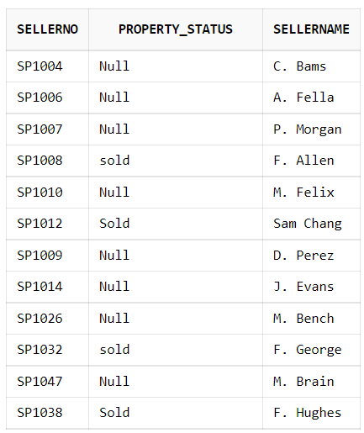

Now back to the question,

We need to join 4 tables together with the code as follows;

SELECT V. AppointmentNo,V. BuyerNumber,V. PropertyCode,P. Buyer_Name AS PotentialBuyer,M. SellerName,L. Address AS Property_Address,S. Staff_name,V. AppointmentDate,V. Appointmenttime

FROM Viewing_Appointment V, Potential_Buyer P, Sale_Property L, Staff_Member S,Seller M

WHERE V. StaffNo = S. StaffNo AND M. SellerNo = L. SellerNo AND V. BuyerNumber = P. BuyerNumber AND L. PropertyCode = V. PropertyCode ;

11/11

